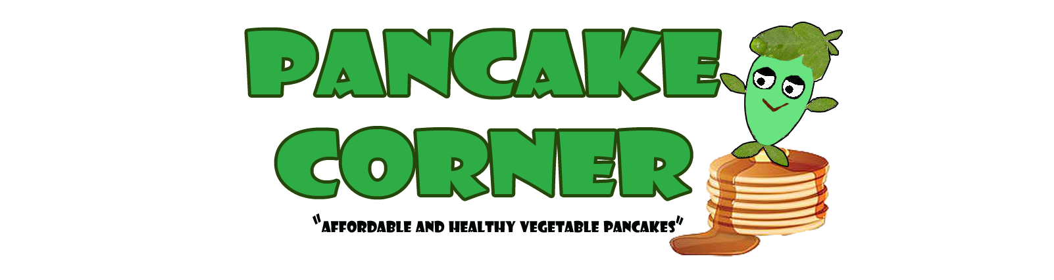

CHAPTER I

INTRODUCTION & BACKGROUND OF THE STUDY

A pancake is a flat cake, often thin, and round, prepared from a starch-based batter and cooked on a hot surface such as a griddle or frying pan. In Britain, pancakes are often unleavened, and resemble a crêpe. In North America, a raising agent is used (typically baking powder). The North American pancake is similar to a Scotch pancake or drop scone

They may be served at any time with a variety of toppings or fillings including jam, fruit, syrup, chocolate chips, or meat. In America, they are typically considered to be a breakfast food. In Britain and the Commonwealth, they are associated with Shrove Tuesday, commonly known as Pancake Day, when perishable ingredients had to be used up before the fasting period of Lent began.

In the Philippines, Banana cream crepes are a popular breakfast and dessert made of very thin pancakes originating from France. It's a common street food that can be found all over the Philippines.

Eating is considered as one of the most important part of our everyday living, without it we can’t expect the life to exist. The food we eat serves as the single source of energy and nutrition and through its consumption we can get a glimpse of one’s lifestyle.
According to the book of Marketing/Management by Mullins et al. “Customer buy benefits not product. When people buy products to satisfy their needs, they are really buying the benefits they believe the product will provide. Rather than the products per se. For instance, you buy headache relief not aspirin.”

Nowadays, people especially high school and college students are eating junk foods and other unhealthy food because of their busyness. For this reason, the proponents decided to put up a food business that will give students healthy food and with less time preparation.


- NAME OF THE COMPANY

All of the proponents’ share their ideal business that they want to put up, and the most common thing that we wanted to do is that we wanted food to be the main focus of our business.
We came up with this idea to promote healthy foods without sacrificing its flavors. We focus on easy to prepare on-the-go food which will be sold in a stall. Initially our stall will be located at Victory Park mall in Antipolo City where college students from Our Lady of Fatima University, La Salle College Antipolo and World Citi Colleges and other nearby schools.
Since most of the proponents are college students, all of us experience going to school with an empty stomach because of cramming preparing for school without having the opportunity to eat breakfast or even lunch.
Our main purpose is to promote healthy lifestyle for high school and college students who need nutrients and energy for them to be energized throughout the day.
Our business will cater to:
Students and health-conscious people alike, the Pancake Corner aim to introduce to the common Filipino palate, an American staple with the convenience of not having to do-it-yourself at home. What sets Pancake Corner apart from other commercial pancake stores, aside from its healthy variety of pancake batter mixes is its affordable price, which will benefit students with tight food budget.
- Company Vision and Mission

VISION
To be the top leading Pancake business offering the finest selections of healthy pancake in the Philippines and eventually the whole world.

MISSION
Pancake corner is devoted to promote a healthy lifestyle to every single Filipino by serving them our unique batter mixtures of budget friendly and healthy pancakes.

- COMPANY LOGO
Figure A

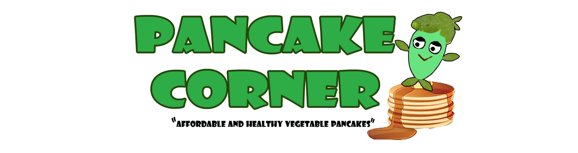
- The company logo consists of a Malunggay character that represents our specialty product which is the Malunggay pancake.
- We choose the color Green to be the motif of our logo because green symbolizes Health, Freshness and Profitability.
- The syrup that flows represents the overflowing benefits and good quality product that we can offer.

COMPANY TAGLINE
“Affordable and Healthy Vegetable Pancakes!”

Our company tagline is very straightforward, we emphasizes the affordability and health benefits of PANCAKE CORNER.

- LOCATION
The exact location of our business stall is Lower G/F B08 Victory Park & Shop, Oliveros Corner M.L. Quezon Street, Barangay San Isidro, Antipolo City, Philippines. Location is one of the most important aspects of a business and choosing a strategic location adds to the success of any business. In this case, the proponents came up with their own standards in choosing the exact location for their business as follows:
- Convenience – The place is convenient for the customers since it is easy to locate. It is also convenient for the business because it is surrounded by wet and dry market for supply needs
- Cost – Since the business is just new, the proponents decide to find low rental cost which is more advisable and economical.
- Customer traffic – the place is a high traffic area since it is surrounded by many school establishments and universities, the well-known Antipolo Cathedral. Municipal hall and the like.
- Safety – The place is landslide and flood free area and the Victory Mall which it’s located has a good security.

LOCATION MAP
Lower G/F B08 Victory Park & Shop, Oliveros Corner M.L. Quezon Street, Barangay San Isidro, Antipolo City, Philippines.
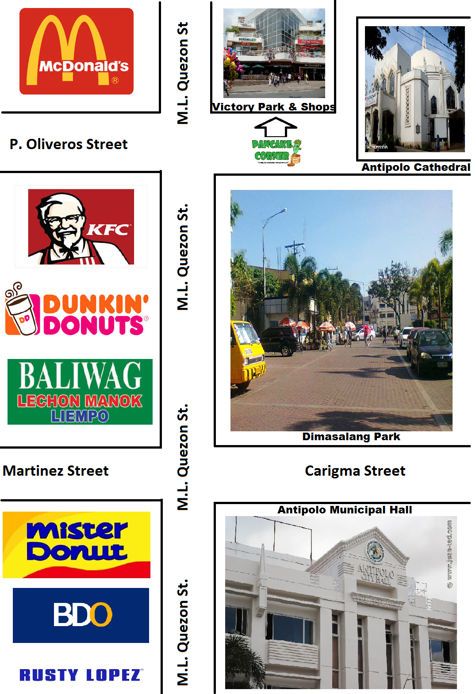
Figure B
- LONG TERM OBJECTIVES
- To sustain the business position in the food industry and in the mind of our customers.
- To be the No. 1 pancake business, offering a variety of healthy pancakes in the Philippines.
- To offer franchise within the next five (5) years.
- To expand our business locally and internationally within five (5) years
- TYPE OF BUSINESS ORGANIZATION
PARTNERSHIP– A partnership is the relationship existing between two or more person who joins to carry on a trade or business. Each person contributes money property, labor or skill and expects to share in the profits and losses of the business.
Some possible pros:
- Shared cost of start-up.
- Shared responsibilities and work.
- Shared business risks and expenses.
- Mutual support and motivation.
Some possible cons:
- Partners in a general partnership are jointly and individually liable for the business activities of the other. If your partner skips town, you’ll be liable for all the debts, not just half of them.
- Shared profits.
- You do not have total control over the business. Decisions are shared, and differences of opinion can lead to disagreements, a “falling out,” or even one partner buying out the other.

- MODE OF FINANCING
The general partners named Mr. Mark Vincent Teodocio, Ms. Mary Catherine Andrade, Ms. Jamaica Dela Cruz, Ms. Marie Chelka San Jose and Ms. Shaira Cervantes had decided to contribute Seventy Thousand Pesos each (P70,000) as starting capital.
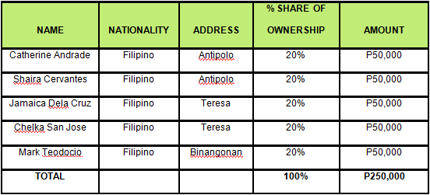

- PRE-OPERATING COST
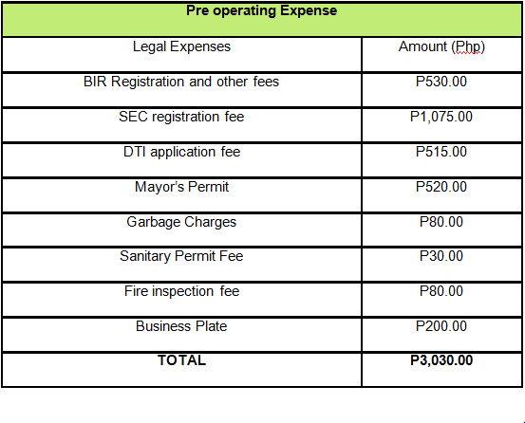
Schedule # 1

- START-UP COST
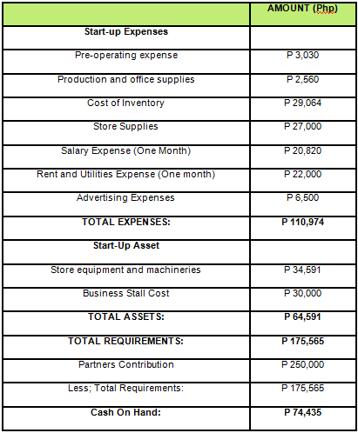
Schedule # 2

- DEFINITION OF TERMS
Pancake – A flat cake made of thin batter and cooked on both sides.
Corner – The point where emerging lines, edges or lines meet.
Affordable – being within the financial means of most people.
Healthy – Enjoying health and vigor of body.
Grab n’ go - To get something quickly
Food stall – Food stall means a vehicle, vessel, aircraft, or structure in, at, or on which food is offered for sale or from which food is sold.

Figure C
- Gantt Chart

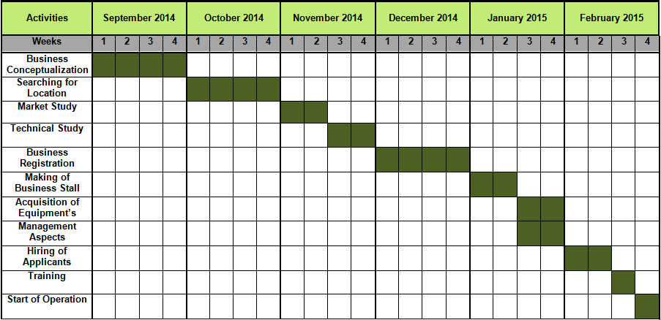



CHAPTER II
MARKET STUDY

- PRODUCT DESCRIPTION
- MAIN PRODUCTS
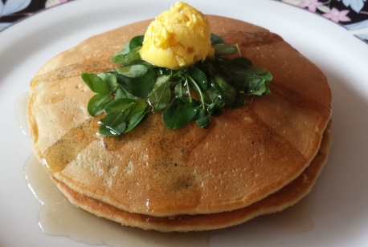 | MALUNGGAY PANCAKE  Classic pancake batter mixed with malunggay leaves and served with butter and pancake syrup.
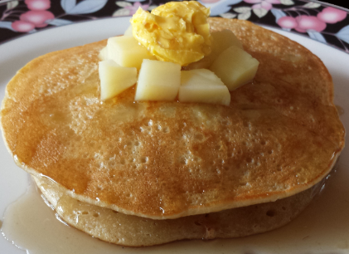 | POTATO PANCAKE  Classic pancake batter mixed with potato bits and served with butter and pancake syrup.
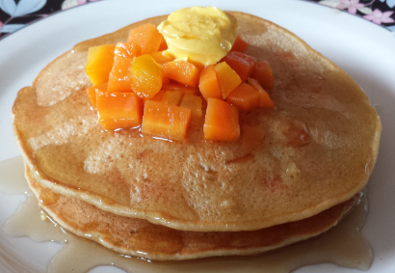 | CARROT PANCAKE  Classic pancake batter mixed with carrot bits served with batter and pancake syrup.
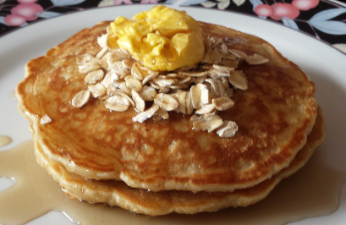 | OATS PANCAKE  Classic pancake batter mixed with oats and served with butter and pancake syrup.
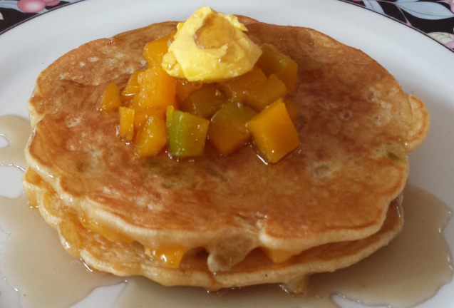 | SQUASH PANCAKE  Classic pancake batter mixed with squash bits and served with butter and pancake syrup.
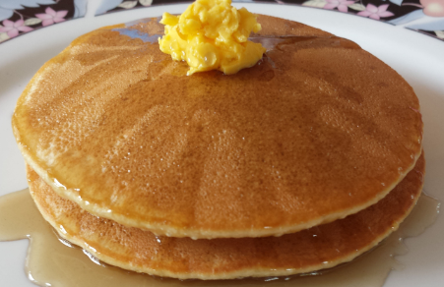 | CLASSIC PANCAKE  Pancake batter served with butter and pancake syrup.

- REFRESHMENTS
ICED TEA MINERAL WATER
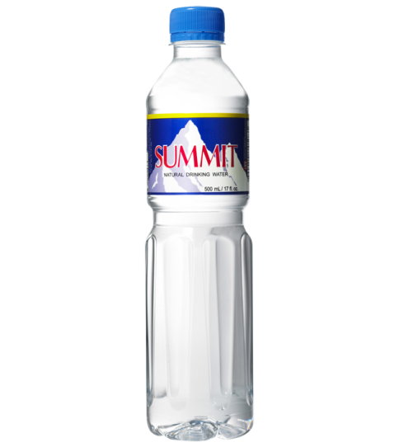
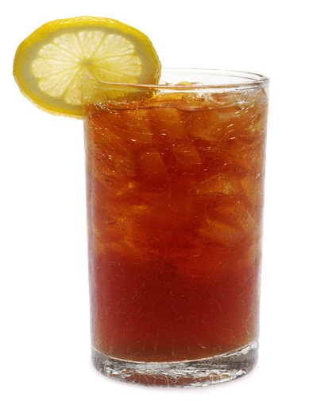

HOT CHOCOLATE COFFEE
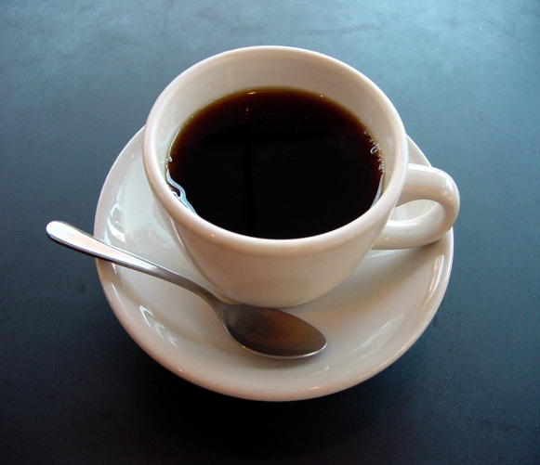
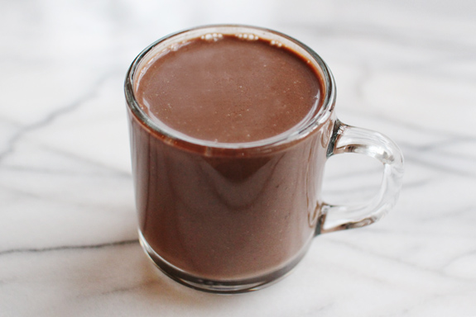

- MARKET DESCRIPTION
A market is consist of individuals who are interested and willing to buy a particular product to obtain benefit that will satisfy a specific need or want, and who have the resources (Time and Money). Every industry is different, and within an industry, there are also different markets. It is important to properly identify your market. Who will be your prospected customers? How much is your share in the market? A business should develop strategies in order to develop its profitability. Thus, in order to develop such strategies. A careful study in the market aspect must be conducted.

- TARGET MARKET
Table 1
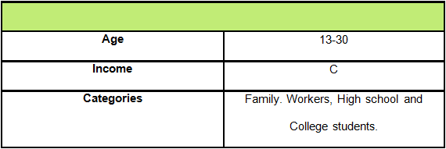

- DEMAND
High demands for Pancakes usually comes from High School and College students. This fact revealed from the survey, where as 43% of the respondents are aged 13-19. This result also supported by the gathered data that 89% of them eats pancake.

- SUPPLY
McDonald’s, according to the survey got the highest percentage as the choice of the market to buy their pancakes. It has 42% respectively. Followed by Jollibee and Pancake Corner who got a 35% and 22%. All of the said competitors are around the surrounding area of the business location

- Target Market share
We only have three (3) major competitors namely McDonalds, The Pancake House and Jollibee. These competitors offer different kinds of pancake. The Pancake House have established name in the food industry. Though their prices are high still it got a market share of 22%. Whereas McDonald’s also known for their affordable pancakes. The survey revealed that it has a market share of 42% and Jollibee with a market share of 35%

In order to get the target market share of Pancake Corner, the proponents anticipated that 6% of the market will switch to a product that is much lower when it comes to price. According to the survey, 58% of the respondents usually spend 30-50Php per serving of pancake.
It will have a target market share of 2% from The Pancake House. Highest target market share of 2% are coming from McDonalds and 2% from Jollibee.

- PRICE STUDY
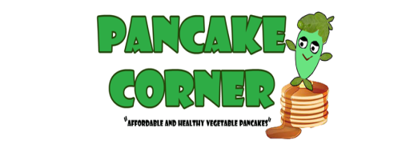
- Pancake Corner Pricelist

Table 2
PRODUCTS | PRICE (Php)
MAIN PRODUCTS
Malunggay Pancake | P 29.00
Carrot Pancake | P 31.00
Potato Pancake | P 31.00
Squash Pancake | P 30.00
Oats Pancake | P 31.00
Classic Pancake | P 29.00
REFRESHMENTS | PRICE
Iced Tea | P 11.00
Coffee | P17.00
Hot Chocolate | P 14.00
Mineral Water | P 13.00

Table 3
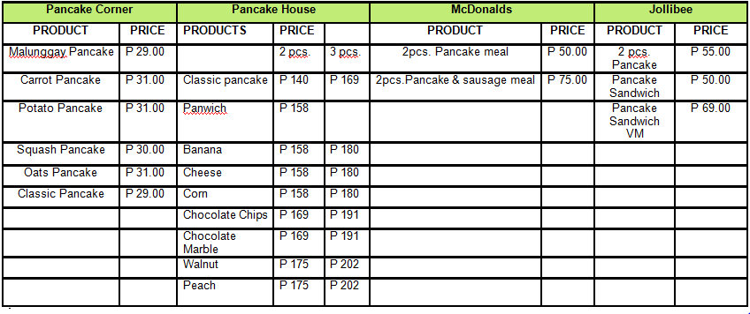
- Comparative Table

- MARKETING PROGRAM

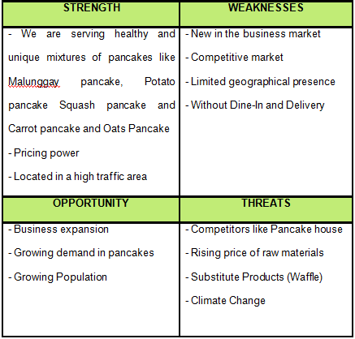
- SWOT ANALYSIS

- POSITIONING STATEMENT
- The Pancake Corner will provide quality food and services at low cost.
- Products are guaranteed served hot and fresh to the customer.
- Customer satisfaction is our priority. And they are treated with importance.

- MARKETING MIX

Marketing mix is a general phrase used to define the different types of choices organizations to make in the whole procedure of carrying a product or service in the market and benefit our business Pancake Corner, we use the following marketing mix:

- PRODUCT- We prefer to serve a healthy mixture of pancake that fits for everyone’s taste. We innovated regular type of pancakes by adding a twist using vegetables.

- PEOPLE – Our success will depend on the perception of our customers in the kind of service that we have. Thus, Pancake Corner staff is required to have good personality, interpersonal skills and a good sense of humor. To attain these we will provide continuous training for our employees.

- PRICE – Our price is affordable so we can assure that the customer will patronize it. Since we are not renting a costly location, we can lower our prices so that the consumers will not shoulder the consequences of the expense.
- PLACE/DISTRIBUTION – Pancake Corner will be located at the center of activity in Antipolo City. The place is high customer traffic area because it is surrounded by establishments and schools/universities.The place is suitable for its visibility and accessibility for potential customers, shoppers, workers, and students.

The distribution of pancake will be direct to the consumer because
Pancake Corner will not use intermediaries as the product will produce per order.

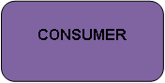
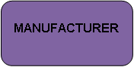

- PACKAGING –Packaging is defined as the wrapping material around a consumer item that serves to contain, identify, describe, protect, display, promote and otherwise make the product marketable and keep it clean. Packaging is the technology of enclosing or protecting products for distribution, storage, sale, and use. Since Pancake Corner is Grab n’ go. The packaging of our products is one of the most important factor that can add to the success of the business. The packaging is made up of Kraft cardboard on the outside and glossy silver coating on the inside. The packaging and labels can be used by Pancake Corner to encourage potential buyers to purchase our products. What we did is we put random Motivational quotations inside the box so that when the consumer opens the packaging it can be a sort of motivation for him throughout the day.

- Packaging Design
Figure D
Structure outside the Box
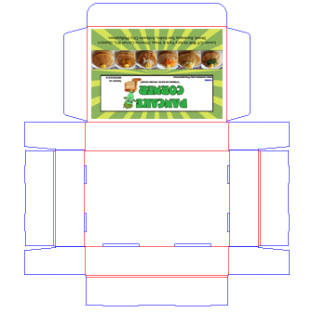

Structure inside the Box
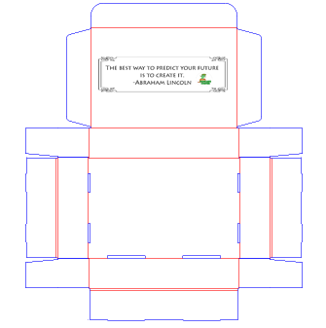
3-Dimensional View Outside
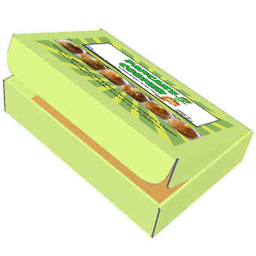

3-Dimensional View Inside
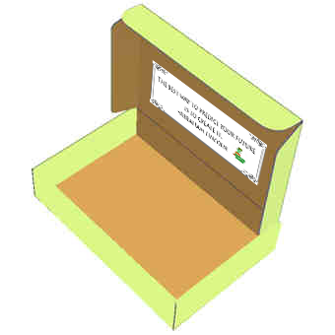

- PROMOTION – We will employ two different marketing tactics to increase customer awareness of Pancake Corner.
- Our most important tactic will be word of mouth/in-store marketing. This will be by far the cheapest and most effective of our marketing programs.
- The second marketing tactic will be the use of tarpaulins and flyers. This will be low budget plans that will provide community awareness for the business.
- The business will also provide free taste for the prospective customers for them to know what Pancake Corner can produce.
- Also, we will provide a Facebook page so that we can use the power of social media and for our customer to interact with us.

Advertising Materials
FIRST TARPAULIN (SOON TO OPEN)
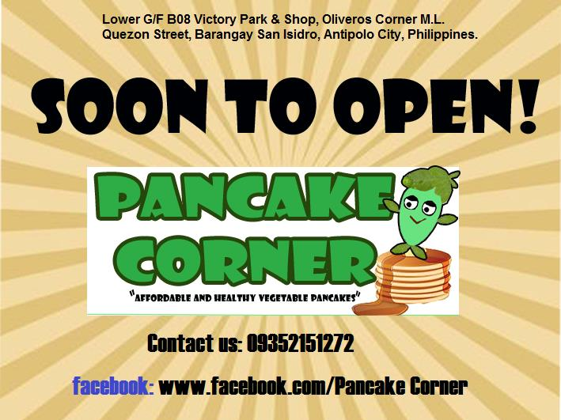
Figure E

SECOND TARPAULIN (GRAND OPENING)
Figure F


FLYERS
Figure G
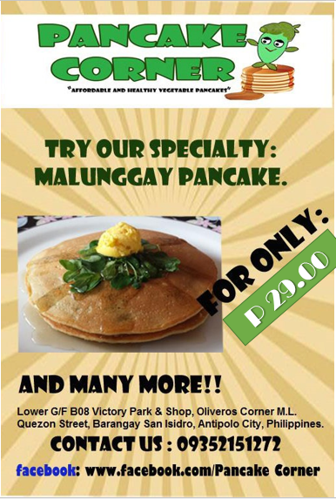

FACEBOOK PAGE
Figure H
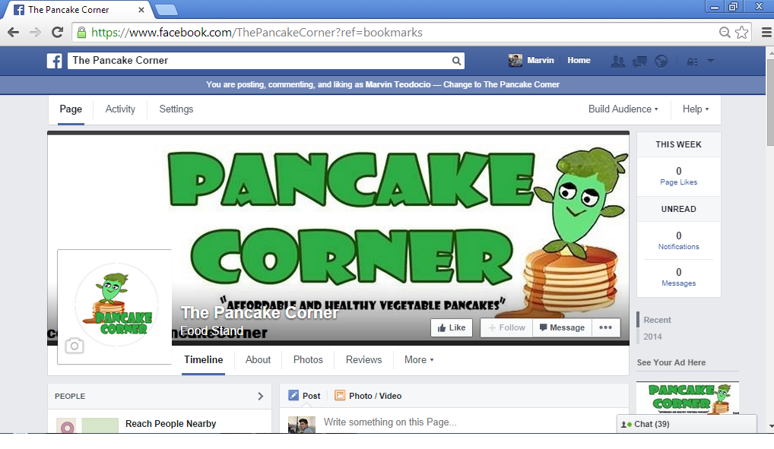

Advertising Expense
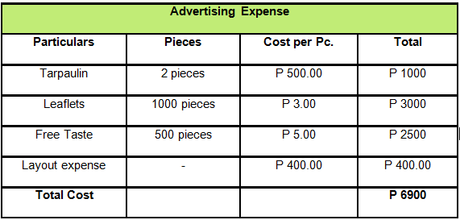
Schedule # 3



CHAPTER III:
TECHNICAL STUDY

- The Product
The Pancake Corner will give its customer a variety of budget friendly pancakes with its aim to promote a healthy lifestyle to our customers. We can guarantee that our products are made from fresh ingredients, since our business location is accessible to the market we can easily catch the attention of our target market, Pancake corner is also unique because we sell different selection of pancake which is Classic, Carrots, Potato, Oats, Squash and also our specialty product Malunggay pancake. We chose Malunggay pancake as our specialty because it gives a lot of benefits to our body, we also offer iced tea, water, coffee and hot chocolate. Our pancakes are served together with pancake syrup and butter.

- Production Process
In the production process, Pancake Corner will cook pancakes per order to avoid excess products and to assure the quality and freshness of the pancakes to be served.

Pancakes:
Table 4

Pancake Corner’s Malunggay Pancake
Ingredients
Malunggay Leaves
Flour
Baking powder
Sugar
Salt
Oil
Evaporated Milk
Butter
Egg
Total:P 42.00
*Makes 6 pieces (6 pieces ÷ 2 = 3 servings)
Procedure:
- Mix all the ingredients to make the batter
- Pour the pancake batter mixed with boiled malunggay leaves in the pancake maker.
- Wait for it to cook.
- Serve with pancake syrup and butter.

Pancake Corner’s Potato Pancake
Ingredients
Potato
Flour
Baking powder
Sugar
Salt
Oil
Evaporated Milk
Butter
Egg
Total:P 46.00
*Makes 6 pieces (6 pieces ÷ 2 = 3 servings)
Procedure:
- Mix all the ingredients to make the batter
- Pour the pancake batter mixed with boiled potato cubes in the pancake maker.
- Wait for it to cook.
- Serve with pancake syrup and butter.
Pancake Corner’s Carrot Pancake
Ingredients
Carrot
Flour
Baking powder
Sugar
Salt
Oil
Evaporated Milk
Butter
Egg
Total:P 46.00
*Makes 6 pieces (6 pieces ÷ 2 = 3 servings)
Procedure:
- Mix all the ingredients to make the batter
- Pour the pancake batter mixed with boiled carrot cubes in the pancake maker.
- Wait for it to cook.
- Serve with pancake syrup and butter
Pancake Corner’s Oats Pancake
Ingredients
Oats
Flour
Baking powder
Sugar
Salt
Oil
Evaporated Milk
Butter
Egg
Total:P 45.00
*Makes 6 pieces (6 pieces ÷ 2 = 3 servings)
Procedure:
- Mix all the ingredients to make the batter
- Pour the pancake batter mixed with oats in the pancake maker.
- Wait for it to cook.
- Serve with pancake syrup and butter.

Pancake Corner’s Squash Pancake
Ingredients
Squash
Flour
Baking powder
Sugar
Salt
Oil
Evaporated Milk
Butter
Egg
Total:P 44.00
*Makes 6 pieces (6 pieces ÷ 2 = 3 servings)
Procedure:
- Mix all the ingredients to make the batter
- Pour the pancake batter mixed with boiled squash cubes in the pancake maker.
- Wait for it to cook.
- Serve with pancake syrup and butter.
Pancake Corner’s Classic Pancake
Ingredients
Flour
Baking powder
Sugar
Salt
Oil
Evaporated Milk
Butter
Egg
Total:P 41.00
*Makes 6 pieces (6 pieces ÷ 2 = 3 servings)
Procedure:
- Mix all the ingredients to make the batter
- Pour the pancake batter mixed with boiled squash cubes in the pancake maker.
- Wait for it to cook.
- Serve with pancake syrup and butter.

Table 5
Pancake Corners Pancake Syrup
Ingredients
Muscovado Sugar
Total: P 44.00
Procedure:
- Simmer a small amount of liquid
- Add Muscovado sugar and stir gradually
- Add Muscovado sugar again and keep on stirring until golden brown
Table 6
Refreshments
Iced tea
Quantity | Ingredients | Cost (Php)
1 pack | Nestea Iced Tea | P 150
Total |  | P 150
*Make 1 full container (20 Servings)

Hot Coffee
Quantity | Ingredients | Cost (Php)
1 pack | 3 in 1 coffee mix | P 120
Total |  | P 120
*Makes 10 Servings
Hot Chocolate
Quantity | Ingredients | Cost (Php)
1 pack | Swiss miss Hot chocolate | P 120
Total |  | P 120
*Makes 12 Servings
Mineral Water
Quantity | Ingredients | Cost (Php)
1 pack | Summit 500ml | P 300
Total |  | P 300
*Makes 32 servings

- Production Cost
Production cost is a cost incurred by a business when manufacturing a good or producing a service. Production costs combine raw material and labor. To figure out the cost of production per unit, the cost of production is divided by the number of units produced. A company that knows how much it will cost to produce an item, or produce a service, will have a clearer picture of how to better price the item or service and what will be the total cost to the company.The desired Mark-up percentage of the Pancake Corner is 40%. The formula for determining a products selling price using the desired mark-up is:
Table 7
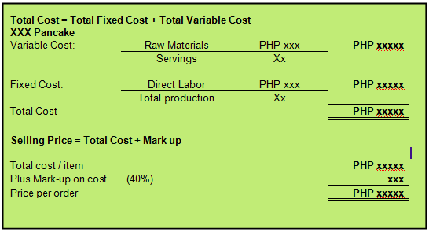
Formula for Costing:

Table 8
Sample costing for pancakes:

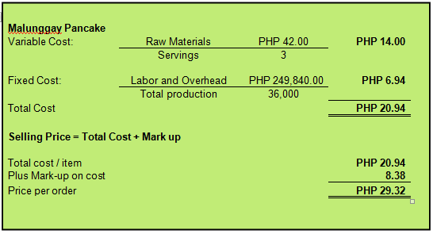
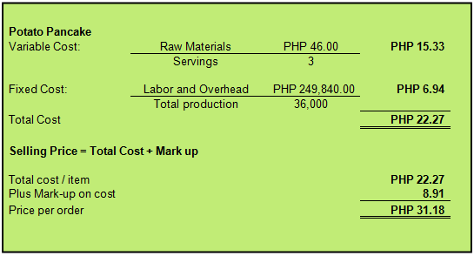
Table 9
Sample costing for refreshments:
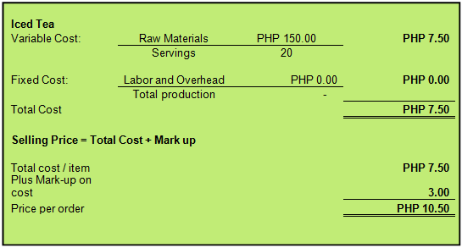
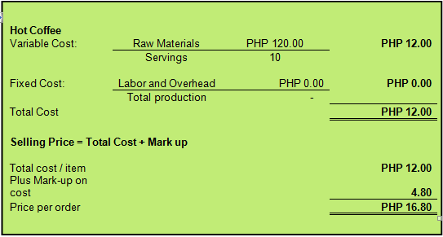

Table 10
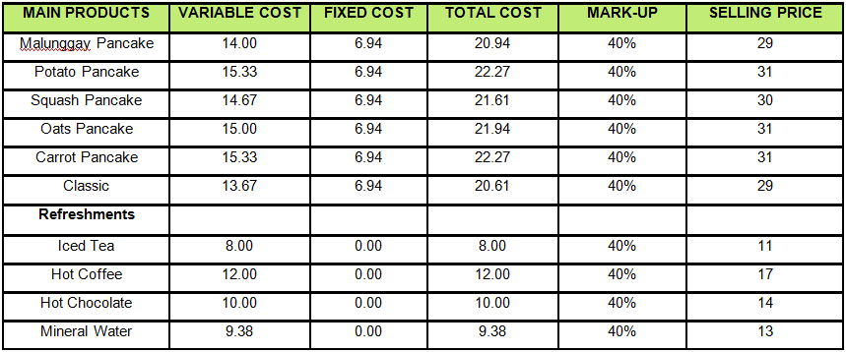
Pricing table

- Flow Chart of Production

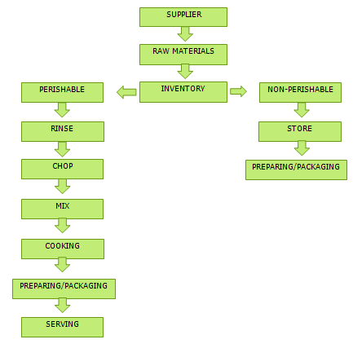

- Flow Chart of Storing

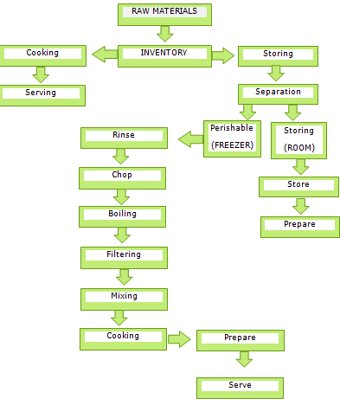

- Production schedule
The stall serves as the plant of the business. All the equipment’s used in everyday production can be found there. The business will open 9:00 am every day. Because that is the operating hours of the location of the business which is the Victory Park & Shop. Thus, the staff must be in the workplace at 8 am for food preparation. The working schedule of the service crews consist of a Morning shift and a Night shift. Daytime schedules begin around 8 a.m. and go through 5 p.m., including a one-hour lunch. An evening shift runs from 1 p.m. to 9 p.m.
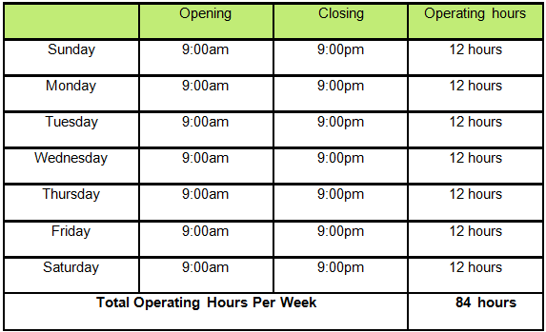
Table 11

- Stall Layout
Left Side View
Figure I
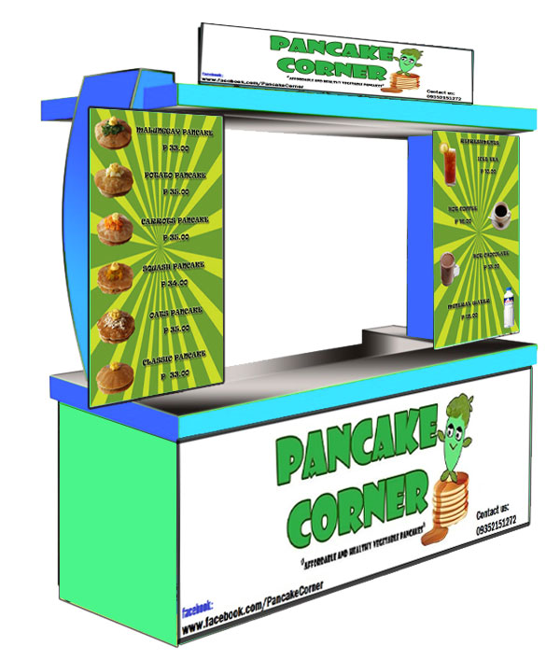
Right Side View
Figure J
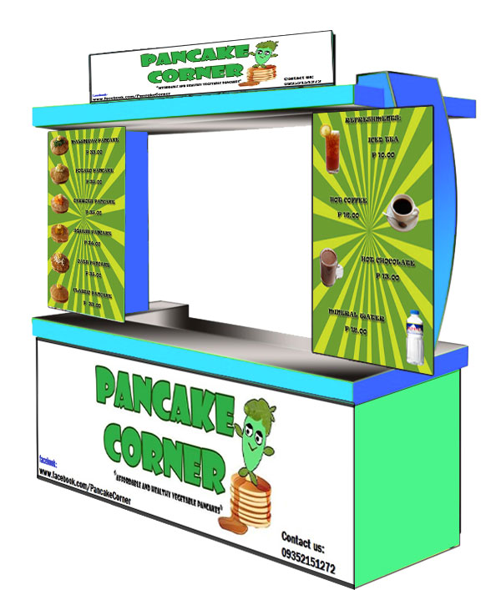

Signage
Figure K
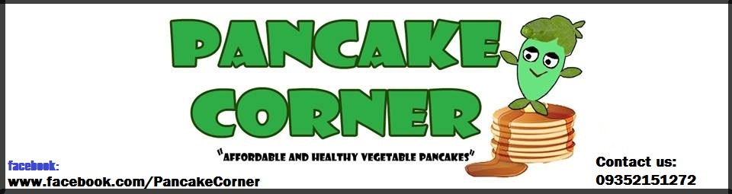
Menu for Main Products
Figure L
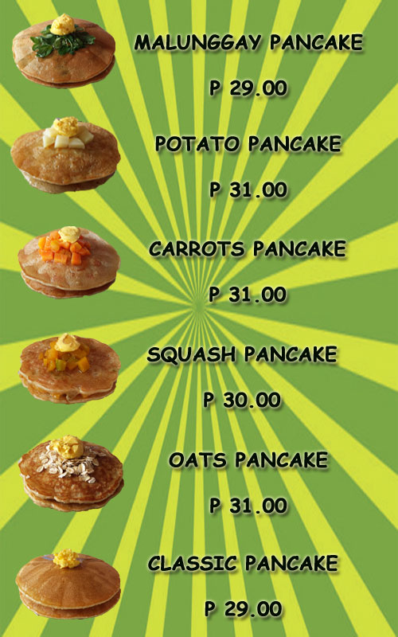

Menu for Refreshments
Figure M
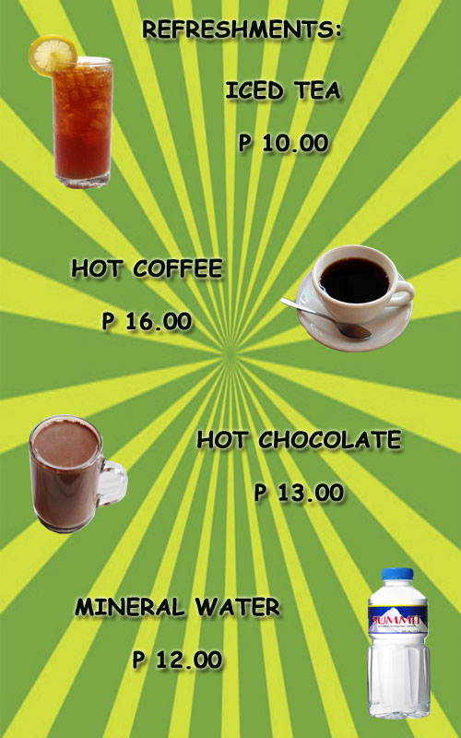
- Store Supplies, Tools & Equipments
STORE EQUIPMENTS AND MACHINERIES
Name |  | Description | Price | Qty | Total
Mixing bowl | 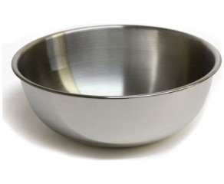 | is a bowl used for mixing of ingredients. | P 139.00 | 2 pc. | P 278.00
Handheld mixer | 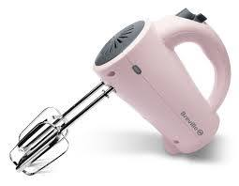 | A portable or hand mixer is an electric handheld mixing tool that has two removable metal beaters and variable speeds. Used to make batter mixtures. | P 950.00 | 1 pc | P 950.00
Measuring spoon | 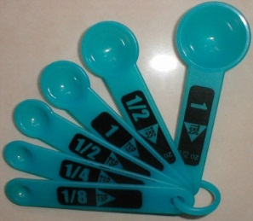 | A measuring spoon is a spoon used to measure an amount of an ingredient, either liquid or dry, when cooking. | P 89.00 | 1 pc | P 89.00
Pancake maker | 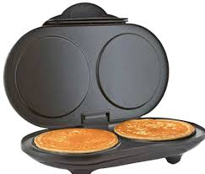 | An electrical device  used to make pancakes | P 1499.00 | 2 pc | P 2998.00
  Compact  refrigerator | 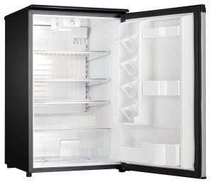 | A compact refrigerator is a refrigerator that is much smaller than the normal refrigerator. Used to store perishable goods and refreshments | P 4995.00 | 1 pc | P 4995.00
Induction Cooker | 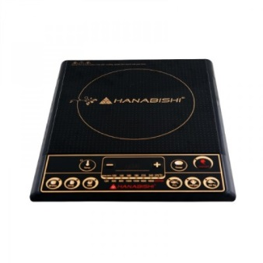 | A cooking vessel by electrical induction, instead of by thermal conduction from a high-temperature source, such as a gas or other flame. | P 1998.00 | 1 pc | P 1998.00
Cooking Pot | 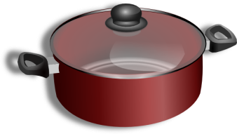 | a container of earthenware, metal, etc., usually round and deep and having a handle or handles and often a lid, used for cooking, serving, and other purposes. | P 500.00 | 1 pc | P 500.00
Chopping Board | 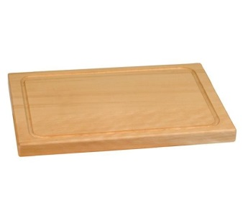 | A cutting board is a durable board on which to place material for cutting. The kitchen cutting board is commonly used in preparing food; other types exist for cutting raw materials | P 146.00 | 2 pc | P 292.00
Knife | 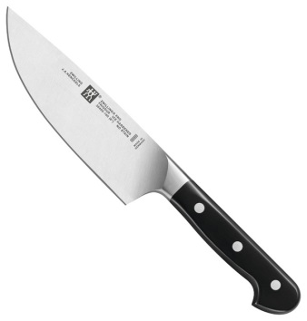 | an instrument composed of a blade fixed into a handle, used for cutting | P 200 | 2 pc | P 400
Acrylic container | 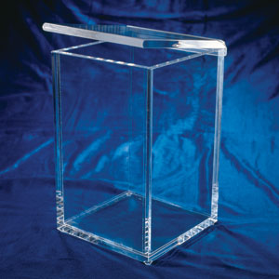 | A container used to hold liquids. | P 1000.00 | 1 pc | P 1000.00
Food warmer | 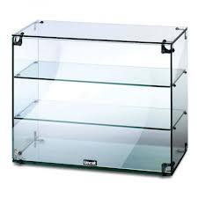 | Hold food at safe temperatures for human consumption. | P 2500.00 | 1 pc | P 2500.00
Ladle | 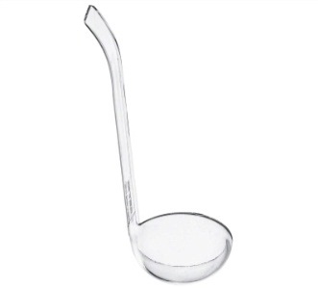 | Used to transfer the liquid from the acrylic container to the paper cup. | P 159.00 | 1 pc | P 159.00
Heater | 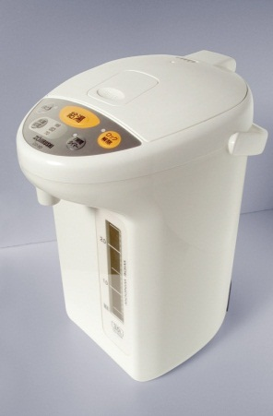 | An electrical device that is used to keep the water warm. | P 1115.00 | 1 pc | P 1115.00
Pail | 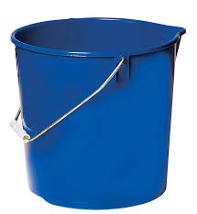 | Used for carrying water | P 190.00 | 1 pc | P 190.00
Trash bin | 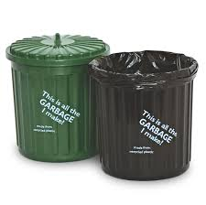 | A container for temporary storing refuse and waste | P 250.00 | 3 pc | P 750.00
Cash Register | 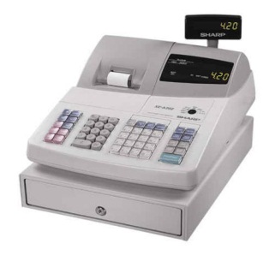 | An electronic device used for calculating and recording sales transaction and an attached cash drawer. | P 15,000.00 | 1 pc | P 15,000.00
Calculator | 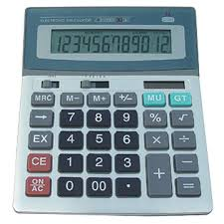 | A device that performs arithmetic operations of numbers. | P 615.00 | 2 pc | P 1,230.00
Stapler | 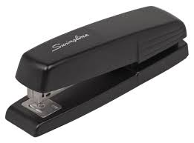 | A mechanical device that joins sheet of paper together. | P 147.00 | 1 pc | P 147.00
TOTAL: |  |  |  |  | P 64.591

PRODUCTION AND OFFICE SUPPLIES
Name |  | Description | Price | Qty | Total
Table napkin | 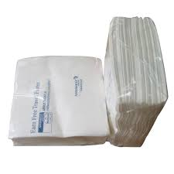 | A square piece of cloth or paper used at a meal to wipe the fingers or lips and to protect garments, or to serve food on. | P 45.00 | 3 Pks | P 135.00
Pancake box | 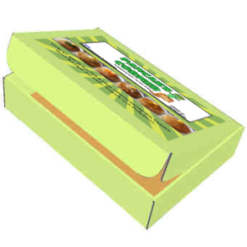 | A Paper Box used to store pancake for takeout. | P 70.00 | 2  Pks | P 140.00
Paper bag |  | A bag made out of paper. Used to keep the freshness of the pancake. | P 155.00 | 1 Pk | P 155.00
Coffee cup | 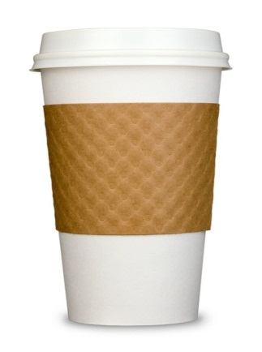 | A cup from which coffee is drunk. Can be used for Hot chocolate drink also. | P 73.00 | 4 Pks | P 292.00
Coffee Stirrer | 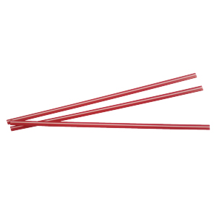 | A tool or device for stirring something. | P 20.00 | 3 Pks | P 60.00
Disposable gloves | 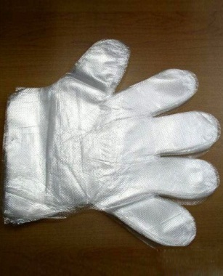 | Used as hygiene and contamination protection measure. Designed for disposal after use. | P 67.00 | 3 Pks | P 201.00
Thermal Paper | 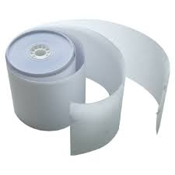 | Used in cash register to make a copy of customers order or receipt. | P 54.00 | 3 Rls | P 162.00
Pencil | 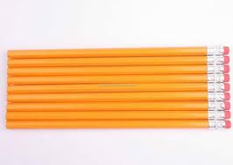 | A writing utensil with a piece of lead or graphite surrounded by wood. Usually with an eraser at one end. | P 25.00 | 1 Pk | P 25.00
Ball pen | 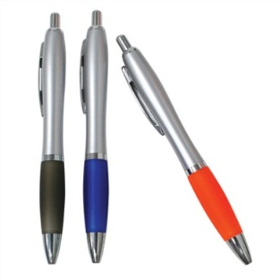 | A device used to apply ink to a surface, usually paper for writing or drawing. | P 30.00 | 1 Pk | P 30.00
Gloves | 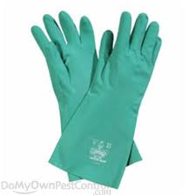 | Used as hygiene and contamination protection measure. | P 77.00 | 2 Pr | P 154.00
Alcohol | 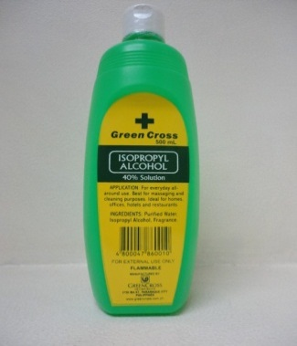 | Use to clean, disinfect  surface etc. | P 75.00 | 2 pc | P 150.00
Sponge | 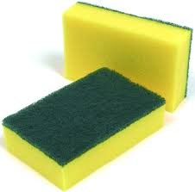 | A sponge used for cleaning tools and equipment’s together with a dishwashing liquid | P 12.00 | 4 pc | P 48.00
Multi  purpose  cleaner  with  sprayer | 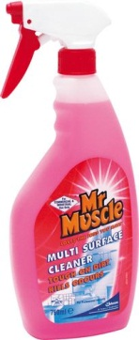 | A multi-purpose glass and surface cleaner. | P 130.00 | 1 pc | P 130.00
Diswashing liquid | 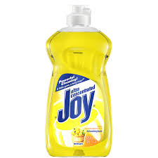 | Used for washing tools and equipment’s | P 200.00 | 1 pc | P 200.00
TOTAL: |  |  |  |  | P 2,560.00

- Building and Facilities
- Rent Expense
The Pancake Corner will rent a space for the stall. The rental amount is 18,000 per month.
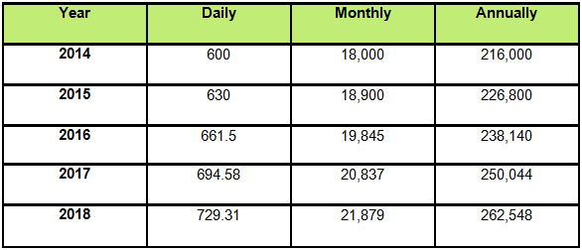
Schedule # 4

Notes: We assumed that the rental cost will increase by 5% annually.

- Stall Cost
The Proponents will consult a stall maker for the making of the business stall to lessen the work. The total cost of the project is amounting to P30, 000.

- Utilities expenses
Utilities are composed of water and electricity expenses. The table below shows the assumptions of the utility expenses that the business might consume.

Electricity Expenses
Schedule # 5
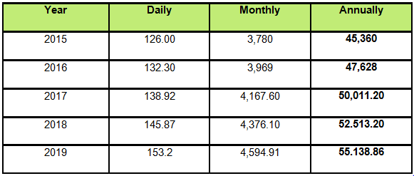Notes: We assumed that the rental cost will increase by 5% annually.

Water Expenses
Schedule # 6
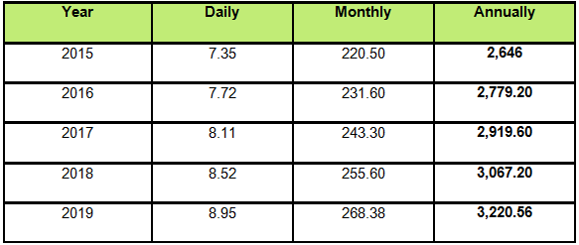Notes: We assumed that the water cost will increase by 5% annually
Total Utilities Expenses
Schedule # 7
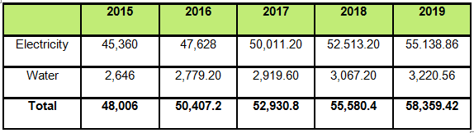

- Waste disposal
Waste management is the collection, transport, processing, recycling or disposal of waste materials. The term usually relates to materials produced by human activity, and is generally undertaken to reduce their effect on health, the environment or aesthetics. Proper waste disposal is a part of our social responsibility. After the business operation, the employees are obligated to bring out all the waste and put it in the right container outside the store to be collected by the garbage collectors. The pancake corner will be engaged in a waste disposal methods called Physical Reprocessing. The popular meaning of ‘recycling’ in most developed countries refers to the widespread collection and reuse of everyday waste materials such as empty beverage containers. These are collected and sorted into common types so that the raw materials from which the items are made can be reprocessed into new products. Material for recycling may be collected separately from general waste using dedicated bins and collection vehicles, or sorted directly from mixed waste streams.

- TIME SCHEDULE
POSITION | TIME | WORKING HOURS
MANAGER | 10:00am-07:00pm | 8Hrs
SERVICE SCREW 1 | 08:00am-05:00pm | 8Hrs
SERVICE SCREW 2 | 01:00pm-09:00pm | 8Hrs



CHAPTER IV:

ORGANIZATIONAL AND MANAGEMENT
STUDY

- Labor Requirements
The organizational structure of the business is composed of manager and two (2) service crew. The manager will manage the overall store operation and will also be responsible for auditing. The service crews will do the inventory and responsible for the cleanliness of the food stall
Organizational structure
Figure N
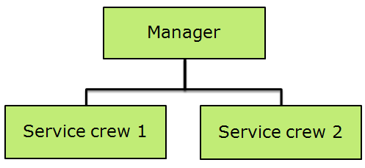
The store managers have the overall authority in the store and two (2) service crews. But since the business is just starting, the owners will act as the store manager to lessen the expense and to personally manage the business.

Personnel Requirements
Table 13
Position | Qualification | Job Description | Qty | Salary
Manager | Proponent/Owner | -Responsible for store operation  -Manages the inventory  -Handles the monetary transaction | 1 | 450/day
Service crews | -male or female  -at least high school diploma  - 18 years old above  -has knowledge of basic arithmetic  -skills in handling and counting cash | -to prepare the pancake by order  -Distribute orders  -maintaining cleanliness in  stall area  -perform other duties when required  - Clean dishes, kitchen, preparation of equipment, and utensils | 2 | 347/day
Total |  |  | 3

Employment requirement
- Birth Certificate
- Bio-data or Resume
- Diploma
- Phil-health
- Pag-ibig
- SSS Number
- TIN Number
- NBI / Police Clearance
B. Company Policies and Regulation
- Hiring
- In hiring process, Applicants must be qualified to meet the set standards required for the job.
- During hiring, Applicants must comply with the needed document.
- Applicants should have a pleasing personality and a good moral character.
- Full time and Part time applicants will be entertained. Even working students are encouraged.
- Training
- Newly hired applicants are required to attend three (3) day orientation and training
- Working schedule
- Employees are required to observe regular and punctual attendance. Absences and tardiness are all counted.
- The service crews will work under opening and closing schedule. Excess of eight (8) hours working days will be paid as overtime. Employees who come beyond opening hours will be considered late.
- In case employees foresee that he/she will be absent, he/she must file a leave of absence.
- Employees will be given a one (1) hour break per day.
- Each employee will be given one (1) day in weekdays for their rest day.
- Rules and Regulations
- Unauthorized usage of company property is strictly prohibited.
- Bringing of unnecessary objects like deadly objects, prohibited drugs and pornographic materials are prohibited.
- “No smoking” and “No drinking of alcohol” are strictly prohibited while working.
- Cleanliness should be observed every time. Avoid littering of any waste to show that the company is environment friendly.
- Always wear proper uniform during work hours. Specially hairnet and caps.
- Always keep the area clean and tidy.

- Code of conduct
- Tardiness
1ST Offense: Employee’s Report
2nd Offense: Appraisal
3rd Offense: 3 days Suspension
4th Offense: Termination

- Absence without due cause
1ST Offense: Employee’s Report
2nd Offense: Appraisal
3rd Offense: 3 days Suspension
4th Offense: Termination

- Negligence of duty
1ST Offense: Employee’s Report
2nd Offense: Appraisal
3rd Offense: 3 days Suspension
4th Offense: Termination

- Immoral conduct
1ST Offense: Employee’s Report
2nd Offense: Appraisal
3rd Offense: 3 days Suspension
4th Offense: Termination

- Theft
1ST Offense: Employee’s Report
2nd Offense: Appraisal
3rd Offense: 3 days Suspension
4th Offense: Termination

- Unauthorized usage of company property.
1ST Offense: Employee’s Report
2nd Offense: Appraisal
3rd Offense: 3 days Suspension
4th Offense: Termination

- Compensation and Other benefits:
- 13th month pay
According to the Philippine Law, Companies are required to give its employee a 13th pay equivalent to 1 month salary. Pancake Corner will be giving its employee a 13th month pay in accordance to the law.
- SSS
As mandated by law, both employer and employees are to contribute for the social security benefits of the employee in the accordance with the following: will give the employees contribution to the employee accordance to the SSS contribution required.
- Phil Health
As mandated by R.A. 7835 on Medicare Program which is administered by the Philippine Health Insurance Corporation (Phil. Health). Both employer and employees are to contribute for the medical insurance benefits of the employees.
- HDMF
Pancake Corner will share the monthly Pag-IBIG contribution made by each employee which is equal to 100 pesos for every employee.

Schedule # 8
Salaries of Employee
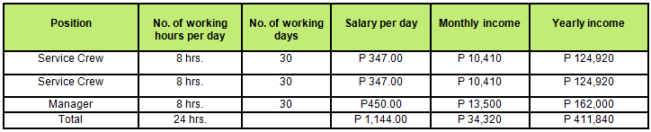

Schedule # 9
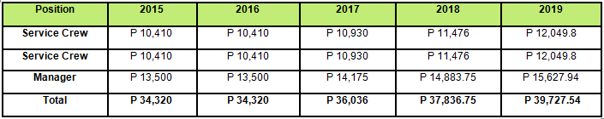
13th Month pay
*Assuming that there will be 5% increase after three (3) years

Schedule # 10

SSS Contribution

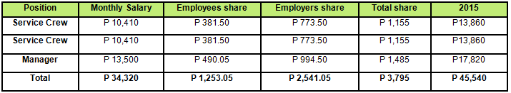

Schedule # 11

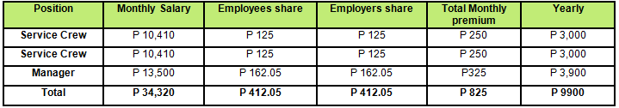
Phil-Health Contribution

Schedule # 12

HDMF Contribution

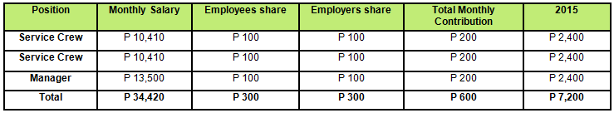

Schedule # 13

Withholding tax
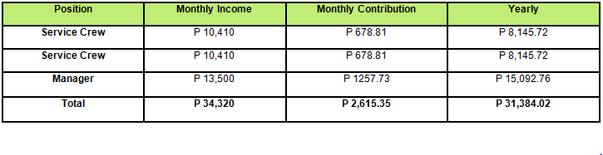

- Uniform of the employees
- Employees represent the company to the customer; therefore they must be well-groomed and well-dressed
- The uniform must be paid or providedby the company
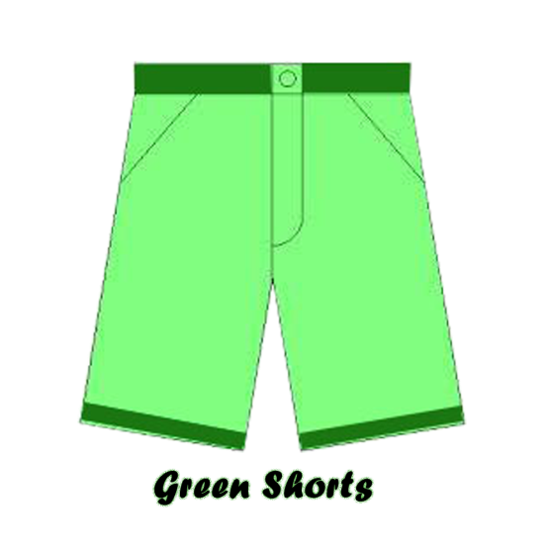
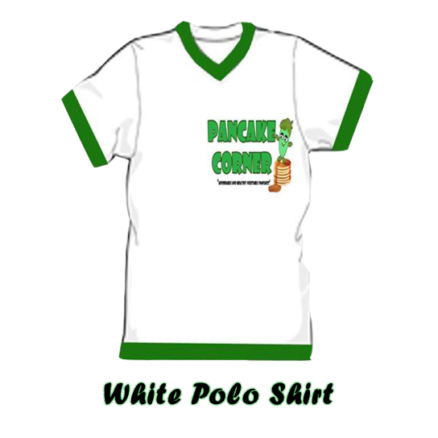
Exhibit P



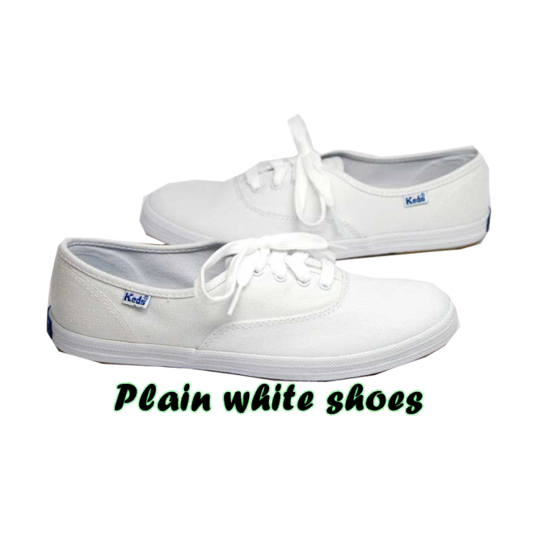


Schedule # 15
Uniform Expenses
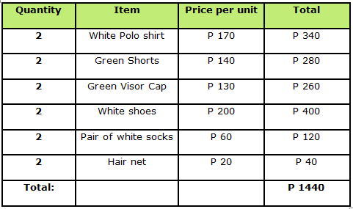



CHAPTER V:

FINANCIAL STUDY

Introduction
In order to establish this firm, the proponents have a total investment of P 250, 000.
Each of them contributed P50, 000 each. From this amount of investment, Expenses like the Pre operating expenses, Acquisition of equipment’s, Administrative expenses as well as the purchase of inventories will be incurred. These composed of the overall project cost amounting to P189, 465.
The excess on the capital contribution (P 60, 535.) serves as the cash reserve of the business.

- Summary of Assumptions
The following are the assumptions made by the proponents for the preparation of financial aspects.
- Sales are assumed to have 5% increases each year.
- Cost of Purchases increases by 5% each year.
- Rent expense has a 5% increase on the third year of operation.
- Salaries expense will increase by 5% on the third year of operation.
- For utilities expense. There will be a 5% increase in electricity and water every year.
- In withholding tax, all employees are assumed single.

- Profit and Loss Distribution
Proponent | Contribution | % of share in Profit/Loss
Mary Catherine Andrade | P 50,000 | 20%
Shaira Cervantes | P 50,000 | 20%
Jamaica Dela Cruz | P 50,000 | 20%
Marie Chelka San Jose | P 50,000 | 20%
Mark Vincent Teodocio | P 50,000 | 20%
TOTAL: | P 250,000 | 100%

PANCAKE CORNER
- Projected Depreciation Expense
For the Years End 2015-2019

 | Cost | Qty. | Total Cost | Useful Life | Yearly Depreciation
Handheld mixer | 950.00 | 1 | 950.00 | 3 | 317
Pancake maker | 1,499.00 | 2 | 2,998.00 | 3 | 999
Induction Cooker | 1,998.00 | 1 | 1,998.00 | 3 | 666
Compact refrigerator | 4,995.00 | 1 | 4,995.00 | 3 | 1,665
Acrylic container | 1,000.00 | 1 | 1,000.00 | 3 | 333
Food warmer | 2,500.00 | 1 | 2,500.00 | 3 | 833
Cash Register | 15,000.00 | 1 | 15,000.00 | 3 | 5,000
Business stall cost | 30,000.00 | 1 | 30,000.00 | 3 | 10,000
TOTAL DEPRECIATION | 55,442.00 |  | 56,941.00 |  | 19,814

- Compensation & Other Expenses

PANCAKE CORNER
- Projected Salaries And Wages
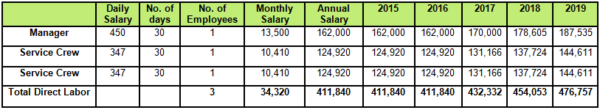
For the Years End 2015-2019
PANCAKE CORNER
- Projected SSS Contribution
For the Years End 2015-2019
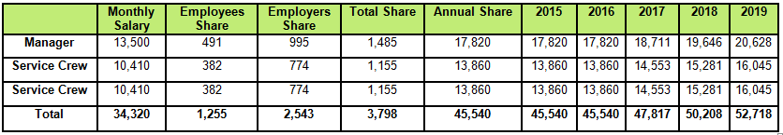

PANCAKE CORNER
- Projected Phil-Health Contribution
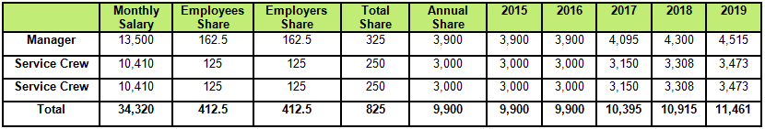
For the Years End 2015-2019

PANCAKE CORNER
- Projected HDMF Contribution
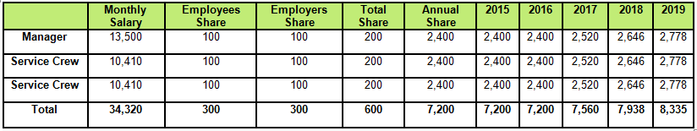
For the Years End 2015-2019

PANCAKE CORNER
- Projected Rent Expense
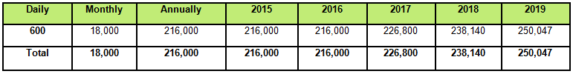
For the Years End 2015-2019

PANCAKE CORNER
- Projected Electricity Expense
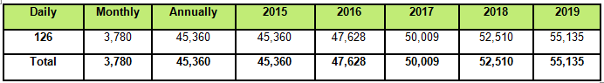
For the Years End 2015-2019

PANCAKE CORNER
- Projected Water Expense
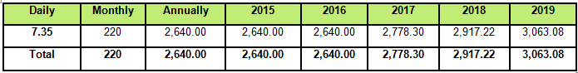
For the Years End 2015-2019

- Financial Statements

PANCAKE CORNER
- Projected Sales
For the Years End 2015-2019
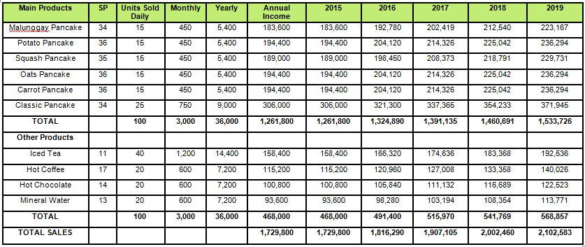
PANCAKE CORNER
- Projected Cost of Inventory
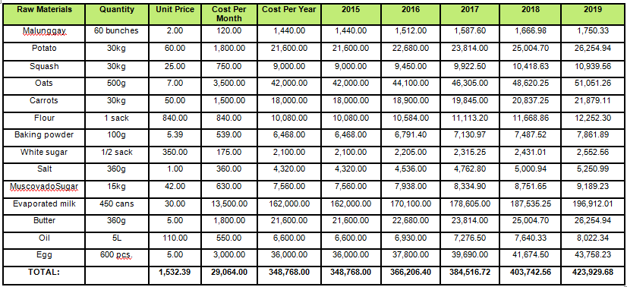
For the Years End 2015-2019

- Store Supplies
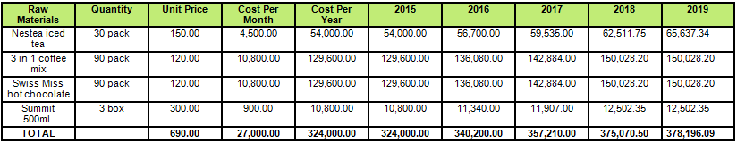

- Cost of Goods Manufactured and Sold
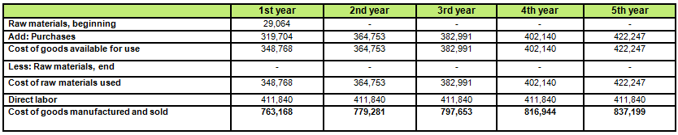


PANCAKE CORNER
- Projected Income Statement
For the Years End 2015-2019

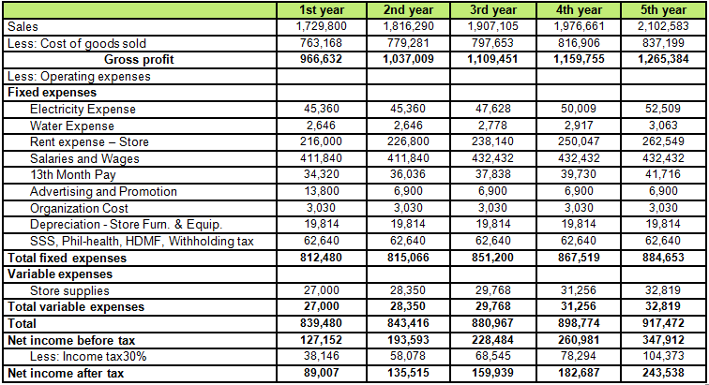

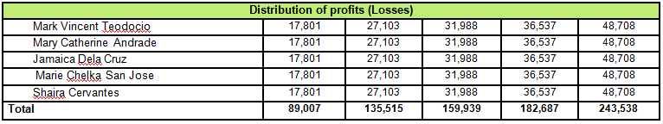

PANCAKE CORNER
- Projected Cash Flow
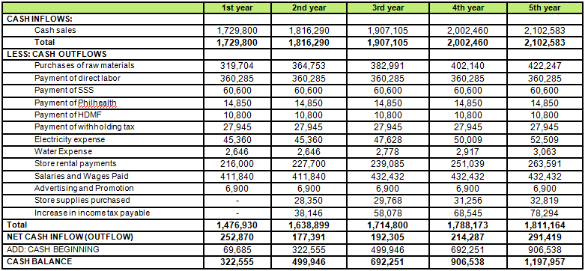
For the Years End 2015-2019

PANCAKE CORNER
- Projected Balance Sheet
For the Years End 2015-2019

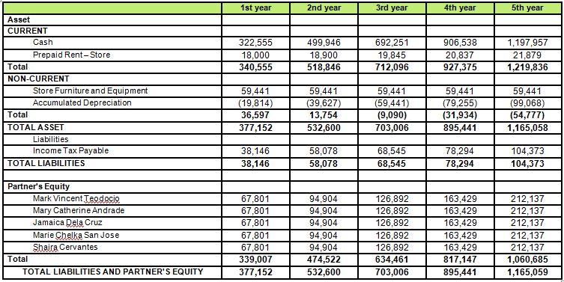

PANCAKE CORNER
- Projected Statement of Partners Equity
For the Years End 2015-2019

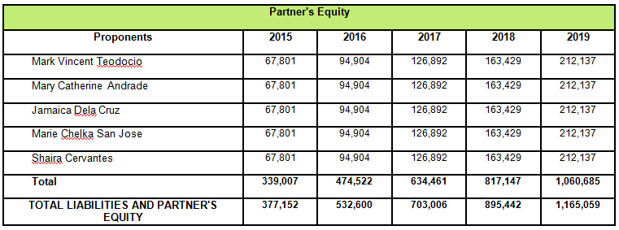

- Financial Analysis

$$A. Current Ratio=\frac{Current Assets}{Current Liabilities}$$
The current ratio is a financial ratio that measures whether or not a firm has enough resources to pay its debts over the next 12 months. It compares a firm’s current assets to its current liabilities
 | 2015 | 2016 | 2017 | 2018 | 2019
Current Assets | 340,555 | 518,846 | 712,096 | 927,375 | 1,219,836
Current Liabilities | 38,146 | 58,078 | 68,545 | 78,294 | 104,373
 | 8.93 | 8.93 | 10.39 | 11.84 | 11.69

$$B. Asset Turnover=\frac{Sales}{Total Assets}$$

Asset turnover is a financial ratio that measures the efficiency of a company's use of its assets in generating sales revenue or sales income to the company.Companies with low profit margins tend to have high asset turnover, while those with high profit margins have low asset turnover.

 | 2015 | 2016 | 2017 | 2018 | 2019
Sales | 1,729,800.00 | 1,816,290.00 | 1,907,104.50 | 1,976,661.23 | 2,102,582.71
Total Assets | 377,152.33 | 532,599.77 | 703,005.80 | 895,441.14 | 1,165,058.49
 | 458.65% | 341.02% | 271.28% | 220.75% | 180.47%

$$C. Debt to Equity=\frac{Total Liabilities}{Partner^{'}s Equity}$$

A measure of a company's financial leverage calculated by dividing its total liabilities by stockholders' equity. It indicates what proportion of equity and debt the company is using to finance its assets.

 | 2015 | 2016 | 2017 | 2018 | 2019
Total Liabilities | 38,145.70 | 58,077.94 | 68,545.19 | 78,294.31 | 104,373.50
Partners' Equity | 339,006.63 | 474,521.83 | 634,460.61 | 817,147.33 | 1,060,685.49
 | 11.25% | 12.24% | 10.80% | 9.58% | 9.84%

$$D. Equity to Assets=\frac{Partner^{'}s Equity}{Total Assets }$$

The equity-to-assets ratio is one of many financial ratios used to determine the financial health and
long-term profitability of a corporation. It is often used by investors to determine whether the corporation's shares are a safe investment. Though important, the equity-to-assets ratio should be
used only with other financial ratios to determine a corporation's overall financial health.
 | 2015 | 2016 | 2017 | 2018 | 2019
Partners' Equity | 339,006.63 | 474,521.83 | 634,460.61 | 817,147.33 | 1,060,685.49
Total Assets | 377,152.33 | 532,599.77 | 703,005.80 | 895,441.14 | 1,165,058.49
 | 89.89% | 89.10% | 90.25% | 91.26% | 91.04%

$$E. Gross Profit Margin=\frac{Gross Profit}{Sales}$$
A financial metric used to assess a firm's financial health by revealing the proportion of money left
over from revenues after accounting for the cost of goods sold. Gross profit margin serves as the
source for paying additional expenses and future savings.
 | 2015 | 2016 | 2017 | 2018 | 2019
Gross Profit | 966,632.00 | 1,037,008.80 | 1,109,451.24 | 1,159,755.48 | 1,265,383.59
Sales | 1,729,800.00 | 1,816,290.00 | 1,907,104.50 | 1,976,661.23 | 2,102,582.71
 | 55.88% | 57.09% | 58.17% | 58.67% | 60.18%

$$F. Net Profit Margin=\frac{Net Income After Tax}{Sales}$$

A ratio of profitability calculated as net income divided by revenues, or net profits divided by sales.
It measures how much out of every dollar of sales a company actually keeps in earnings.
 | 2015 | 2016 | 2017 | 2018 | 2019
Net Income After Tax | 89,006.63 | 135,515.19 | 159,938.78 | 182,686.72 | 243,538.16
Sales | 1,729,800.00 | 1,816,290.00 | 1,907,104.50 | 1,976,661.23 | 2,102,582.71
 | 5.15% | 7.46% | 8.39% | 9.24% | 11.58%

$$G. Return to equity=\frac{Net income after tax}{Partner^{'}s Equity}$$

The amount of net income returned as a percentage of shareholders equity. Return on equity
measures a corporation's profitability by revealing how much profit a company generates with the
money shareholders have invested.
 | 2015 | 2016 | 2017 | 2018 | 2019
Net Income After Tax | 89,006.63 | 135,515.19 | 159,938.78 | 182,686.72 | 243,538.16
Partners' Equity | 339,006.63 | 474,521.83 | 634,460.61 | 817,147.33 | 1,060,685.49
 | 26.26% | 28.56% | 25.21% | 22.36% | 22.96%

$$H. Return on Assets=\frac{Net income after tax}{Total Asset}$$

An indicator of how profitable a company is relative to its total assets. ROA gives an idea as to how efficient management is at using its assets to generate earnings. Calculated by dividing a company's annual earnings by its total assets, ROA is displayed as a percentage. Sometimes this is referred to
as "return on investment".
 | 2015 | 2016 | 2017 | 2018 | 2019
Net Income After Tax | 89,006.63 | 135,515.19 | 159,938.78 | 182,686.72 | 243,538.16
Total Assets | 377,152.33 | 532,599.77 | 703,005.80 | 895,441.14 | 1,165,058.49
 | 23.60% | 25.44% | 22.75% | 20.40% | 20.90%



CHAPTER V:

SOCIO-ECONOMIC STUDY

- Contribution to the Community
The business will contribute to the community by promoting good nutrition, because the products are healthy and rich with nutrients. The business will also contribute in terms of providing job to the people in the community.
- Contribution to the Government
The business will contribute to the government (Municipality of Antipolo) in terms of paying the right amount of taxes and also the collected amount on the permits needed for the business operation.
- Contribution to the Economy
The business is assured to comply with the social and government responsibilities. The Pancake Corner will use resources that are eco-friendly and not dangerous to the environment. The business will use paper boxes, paper bags and paper cups to carry and present our products.

Conclusion:
Based on the study that is conducted by the proponents. We conclude that establishing Pancake Corner will be effective and feasible. With a high demand of pancake and fast growing food industry. Using the marketing strategies and the low prices of our products for our target market can attract them to continuously support our business serving them a variety of unique pancake mixtures and other product offered. Good customer relationship and management will keep them patronizing our products.

APPENDICES

Table 1
Population Growth Rate of Antipolo City
Year | Population of Antipolo
2010 | 677,741
2011 | 720,439
2012 | 765,826
2013 | 814,073
2014 | 850,707
Source:Antipolo City Municipal Hall
Take the population for last year (2014) | 850,707
Less the population for first year (2010) | 677,741
The difference increase (Decrease) | 172,966
172,966 divided by 5 years | 34,593.2

Total Projected Target Market
2015(850,707)+34,593.2 | 885,300.2
2016(885,300.2)+34,593.2 | 919,893.4
2017(919,893.4)+34.593.2 | 954,486.6
2018(954,486.6)+34,593.2 | 989,079.8
2019(989,079.8)+34.593.2 | 1,023,673
Table 2
Population per Barangay in Antipolo City. (District I)
BARANGAY | POPULATION
BagongNayon | 56,675
Beverly Hills | 1,996
De La Paz | 76,920
Mambugan | 60,560
Mayamot | 61,597
Muntindilaw | 12,331
San Isidro | 72,093
Sta. Cruz | 69,068
TOTAL: | 411,254
Population per Barangay in Antipolo City (District II)
BARANGAY | POPULATION
Calawis | 5,337
Cupang | 105,672
Dalig | 57,495
Inarawan | 22,626
San Jose | 110,737
San Juan | 10,654
San Luis | 61,229
San Roque | 65,701
TOTAL: | 439,451
Source: Antipolo City Municipal Hall

Table 3
Household Population of San Isidro (Pob.)
AGES | TOTAL | MALE | FEMALE
TOTAL | 72,093 | 35,938 | 36,155
0-4 | 8,057 | 4,204 | 3,853
5-9 | 7,953 | 4,098 | 3,855
10-14 | 8,086 | 4,141 | 3,945
15-19 | 7,637 | 3,848 | 3,788
20-24 | 6,633 | 3,248 | 3,384
25-29 | 6,174 | 2,985 | 3,189
30-34 | 5,749 | 2,874 | 2,874
35-39 | 5,072 | 2,536 | 2,537
40-44 | 4,392 | 2,135 | 2,257
45-49 | 3,579 | 1,779 | 1,800
50-54 | 2,941 | 1,466 | 1,475
55-59 | 2,217 | 1,093 | 1,123
60-64 | 1,524 | 719 | 805
65-59 | 890 | 394 | 496
70-74 | 615 | 246 | 369
75-79 | 333 | 103 | 230
80 and over | 242 | 68 | 174
Source: Antipolo City Municipal Hall

- SUPPLY
McDonald’s, according to the survey got the highest percentage as the choice of the market to buy their pancakes. It has 42% respectively. Followed by Jollibee and Pancake Corner who got a 35% and 22%. Most
of the said competitors are around the surrounding area of the business location

- Target Market share
We only have three (3) major competitors namely McDonalds, The Pancake House and Jollibee. These competitors offer different kinds of pancake. The Pancake House have established name in the food industry. Though their prices are high still it got a market share of 22%.Whereas McDonald’s also known for their affordable pancakes. The survey revealed that it has a market share of 42% and Jollibee with a market share of 35%
In order to get the target market share of Pancake Corner, the proponents anticipated that 6% of the market will switch to a product that is much lower when it comes to price. According to the survey, 58% of the respondents usually spend 30-50Php per serving of pancake.
It will have a target market share of 2% from The Pancake House. Highest target market share of 2% are coming from McDonalds and 2% from Jollibee.

- MARKET RESEARCH

Most of the Respondents are Teenagers. 43% of the respondents ages 13-19 followed by ages 25-29 who got 31% respectively. And 20-24 with a percentage of 26%.

According to the survey 51% of the Respondents are Male, and 49% are female.

The survey revealed that almost half of the respondents have P5, 000 income every month, and 23% of them who have P5, 000-10, 000. Followed by P15, 000-P20, 000 that got 17% and the least is P10, 000-15,000 which got 10%.

The survey revealed that 50% of the respondents are having P51-P100 as their daily budget for food. And 20% of them are having P101-P150 Followed by the fact that 20% of them have a budget of P151-P200. And the least is that 10% of the respondents has a P0-P50 allowance for food in day to day basis.

The survey revealed the fact that89% of our respondents eats pancake, 8% eats pancake sometimes and only 3% do not.

According to the survey, almost 44% of the proponents usually eats pancake weekly.

According to the survey, 58% says that they spending Php30.00-50.00 per serving for pancake, 36% answers Php15.00-30.00 and 5% arte spending Php50.00-100.00 per serving. It only means that our consumer can afford our set of prices.

The survey revealed the fact that McDonalds got the highest percentage as the choice of the market to buy their pancake.

The survey revealed that Quality is the major factor that they consider when buying a pancake.

According to the survey 97% said that they are health conscious. Since were promoting healthy pancake it’s a good indication for our business.

The survey revealed that 91% of our respondents are eating vegetables and only 9% are not eating vegetables.

Most of our respondents are willing to eat vegetable pancake it got 85% and only 15% says maybe.

46% says that they eat Malunggay, 16% are eating squash, 27% are eating potato and 11% are eating carrots. It’s a good indication for us because Malunggay Pancake is what we are offering to the market as our specialty product.

Almost 85% of the respondents are willing to try new taste of pancake, 15% says No

Almost 97% of our respondents prefer drinks along with their pancakes.

The survey revealed that 37% of our respondents says that they want hot chocolate along with their pancake, 33% want iced tea, 17% preferred coffee and 9% mineral water.

The survey revealed the fact that almost 78% of our respondents prefers Paper box for their pancakes and 22% prefers Styrofoam.

According to the survey, almost half of our respondents wanted their pancakes to be served in just 4-6 minutes.

Survey Form

Legal Documents

Curriculum Vitae

Bibliography

